**What is RAID structure in OS? What are the different levels of RAID configuration?**

RAID (Redundant Arrays of Independent Disks) is a method used to store data on Multiple hard disks therefore it is considered as data storage virtualization technology that combines multiple hard disks. It simply balances data protection, system performance, storage space, etc. It is used to improve the overall performance and reliability of data storage. It also increases the storage capacity of the system and its main purpose is to achieve data redundancy to reduce data loss.   
  
**Different levels of RAID**  
  
Nowadays, RAID is available in various schemes or RAID level as given below:

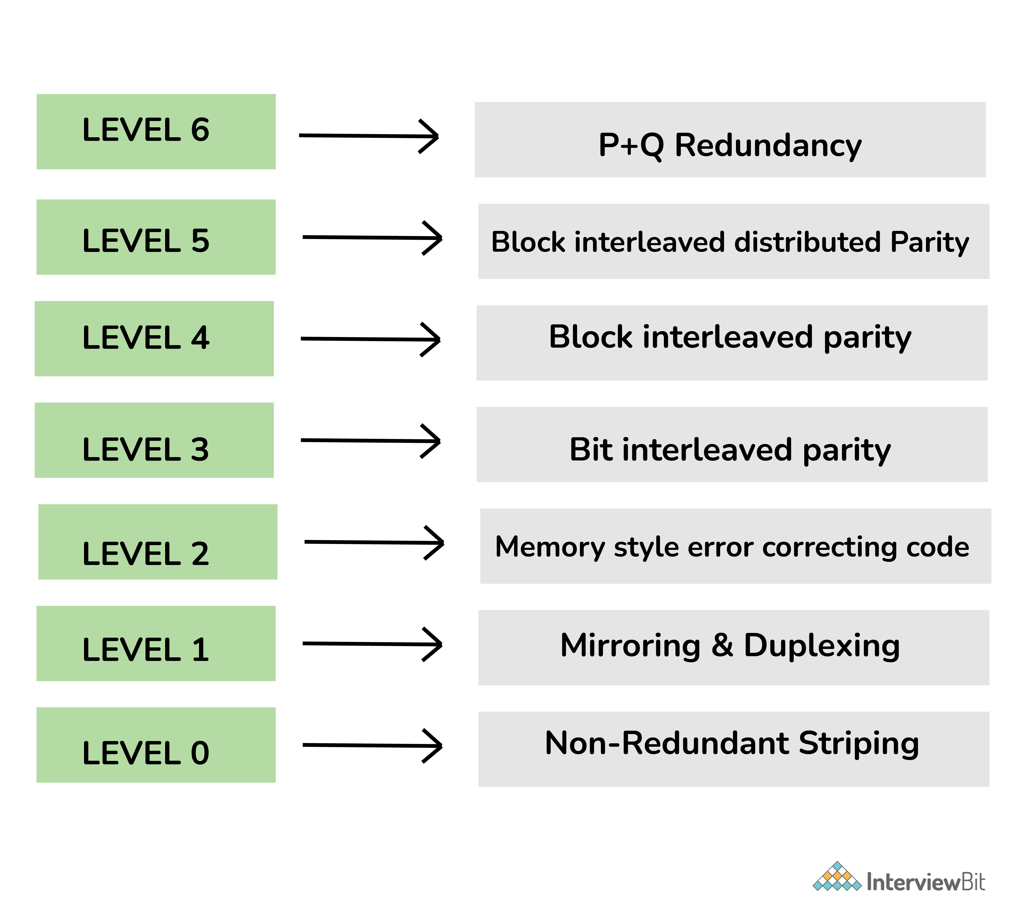

* RAID 0 - Non-redundant striping: This level is used to increase the performance of the server.
* RAID 1 - Mirroring and duplexing: This level is also known as disk mirroring and is considered the simplest way to implement fault tolerance.
* RAID 2 - Memory-style error-correcting codes: This level generally uses dedicated hamming code parity I.e., a liner form of error correction code.
* RAID 3 - Bit-interleaved Parity: This level requires a dedicated parity drive to store parity information.
* RAID 4 - Block-interleaved Parity: This level is similar to RAID 5 but the only difference is that this level confines all parity data to a single drive.
* RAID 5 - Block-interleaved distributed Parity: This level provides far better performance than disk mirroring and fault tolerance.
* RAID 6 - P+Q Redundancy: This level generally provides fault tolerance for two drive failures.

**What is IPC? What are the different IPC mechanisms?**

IPC (Interprocess Communication) is a mechanism that requires the use of resources like a memory that is shared between processes or threads. With IPC, OS allows different processes to communicate with each other. It is simply used for exchanging data between multiple threads in one or more programs or processes. In this mechanism, different processes can communicate with each other with the approval of the OS.

**Different IPC Mechanisms:**

* Pipes
* Message Queuing
* Semaphores
* Socket
* Shared Memory
* Signals

### What do you mean by overlays in OS?

Overlays is basically a programming method that divides processes into pieces so that instructions that are important and need can be saved in memory. It does not need any type of support from the OS. It can run programs that are bigger in size than physical memory by only keeping only important data and instructions that can be needed at any given time.

**What is Reentrancy?**

Reentrant is simply a function in which various clients can use and shares a single copy of a program during a similar period. This concept is generally associated with OS code and does not deal with concurrency. It has two major functions:

* Program code cannot change or modify itself.
* Local data for every client process needs to be stored in different disks.

**What do you mean by asymmetric clustering?**

Asymmetric Clustering is generally a system in which one of the nodes among all nodes is in hot standby mode whereas the rest of all nodes run different applications. It simply uses whole or entire hardware resources therefore it is considered a more reliable system as compared to others.

### What do you mean by Sockets in OS?

The socket in OS is generally referred to as an endpoint for IPC (Interprocess Communication). Here, the endpoint is referred to as a combination of an IP address and port number.  Sockets are used to make it easy for [software developers](https://www.scaler.com/courses/full-stack-developer/) to create network-enabled programs. It also allows communication or exchange of information between two different processes on the same or different machines. It is mostly used in client-server-based systems.   
  
**Types of Sockets**  
  
There are basically four types of sockets as given below:

* Stream Sockets
* Datagram Sockets
* Sequenced Packet Sockets
* Raw Sockets

**28. Explain zombie process?**

Zombie process, referred to as a defunct process, is basically a process that is terminated or completed but the whole process control block is not cleaned up from the main memory because it still has an entry in the process table to report to its parent process. It does not consume any of the resources and is dead, but it still exists. It also shows that resources are held by process and are not free.

### 29. What do you mean by cascading termination?

Cascading termination is a process termination in which if the parent process is exiting or terminating then the children process will also get terminated. It does not allow the child to continue processing as its parent process terminates. It is generally initiated by OS

### What is SMP (Symmetric Multiprocessing)?

SMP is generally referred to as computer architecture in which the processing of programs is done by multiple processors that share a common OS and memory. SMP is very much required if you want to take advantage of multiprocessor hardware. It simply enables any processor to work on any of the tasks no matter where data or resources for that particular task are located in memory. These systems are more reliable than single-processor systems

### What do you mean by Belady’s Anomaly?

In the Operating System, process data is loaded in fixed-sized chunks and each chunk is referred to as a page. The processor loads these pages in the fixed-sized chunks of memory called frames. Belady’s Anomaly is a phenomenon in which if we increase the number of frames in memory, then the number of page faults also increases. It is generally experienced when we use FIFO (First in First out) page replacement algorithm.

### 43. What is spooling in OS?

Spooling simply stands for Simultaneous peripheral operations online. It is referred to as putting data of various I/O jobs in a buffer. Here, buffer means a special area in memory or hard disk that can be accessible to an I/O device. It is used for mediation between a computer application and a slow peripheral. It is very useful and important because devices access or acquire data at different rates. This operation also uses disk as a very large buffer and is capable of overlapping I/O operations for one task with processor operations for another task.

### 52. When is a system in a safe state?

The set of dispatchable processes is in a safe state if there exists at least one temporal order in which all processes can be run to completion without resulting in a deadlock.

**What is the use of Dispatcher in Operating Systems?**

After the scheduler completes the process scheduling, a unique application called a dispatcher enters the picture. The dispatcher is the one who moves a process to the desired state or queue once the scheduler has finished its selection task. The module known as the dispatcher is what grants a process control over the CPU once the short-term schedule has chosen it.

What is Address Translation in Paging?

Logical and physical memory addresses, both of which are distinct, are the two types of memory addresses that are employed in the paging process. The logical address is the address that the CPU creates for each page in the secondary memory, but the physical address is the actual location of the frame where each page will be allocated. We now require a technique known as address translation carried out by the page table in order to translate this logical address into a physical address.

81) What is Translational Look Aside Buffer?

Whenever logical address is created by the Central Processing Unit (CPU), the page number is stored in the Translational Look Aside Buffer. Along, with the page number, the frame number is also stored.

### 3. What is Cycle Stealing?

cycle stealing is a method of accessing computer memory (RAM) or bus without interfering with the   CPU. It is similar to direct memory access (DMA) for allowing I/O controllers to read or write RAM without CPU intervention.

### 54. What are a Trap and Trapdoor?

A trap is a software interrupt, usually the result of an error condition, and is also a non-maskable interrupt and has the highest priority Trapdoor is a secret undocumented entry point into a program used to grant access without normal methods of access authentication.

### 82. Define the Compaction?

The process of collecting fragments of available memory space into contiguous blocks by moving programs and data in a computer’s memory or disk.

### 86. What is “Locality of reference”?

The locality of reference refers to a phenomenon in which a computer program tends to access the same set of memory locations for a particular time period. In other words, Locality of Reference refers to the tendency of the computer program to access instructions whose addresses are near one another.

### How Are Server Systems Classified?

Server systems can be classified as either computer-server systems or file server systems. In the first case, an interface is made available for clients to send requests to perform an action. In the second case, provisions are available for clients to create, access and update files.

.